ASSIGNMENT 9.3
NoSQL with example
A NoSQL (originally referring to "non SQL" or "non relational") database provides a mechanism for storage and retrieval of data that is modeled in means other than the tabular relations used in relational databases
NoSQL encompasses a wide variety of different database technologies that were developed in response to the demands presented in building modern applications:
- Developers are working with applications that create massive volumes of new, rapidly changing data types — structured, semi-structured, unstructured and polymorphic data.
- Long gone is the twelve-to-eighteen month waterfall development cycle. Now small teams work in agile sprints, iterating quickly and pushing code every week or two, some even multiple times every day.
- Applications that once served a finite audience are now delivered as services that must be always-on, accessible from many different devices and scaled globally to millions of users.
- Organizations are now turning to scale-out architectures using open source software, commodity servers and cloud computing instead of large monolithic servers and storage infrastructure.
Relational databases were not designed to cope with the scale and agility challenges that face modern applications, nor were they built to take advantage of the commodity storage and processing power available today.

Spin up a NoSQL cluster in minutes with the MongoDB Atlas: Hosted Database as a Service
Try out the easiest way to start learning and prototyping applications on MongoDB, the leading non-relational database.
Launching an application on any database typically requires careful planning to ensure performance, high availability, security, and disaster recovery – and these obligations continue as long as you run the application. With MongoDB Atlas, you receive all of the features of MongoDB without any of the operational heavy lifting, allowing you to focus instead on learning and building your apps. Features include:
- On-demand, pay as you go model
- Seamless upgrades and auto-healing
- Fully elastic. Scale up and down with ease
- Deep monitoring & customizable alerts
- Highly secure by default
- Continuous backups with point-in-time recovery

NoSQL Database Types
- Document databases pair each key with a complex data structure known as a document. Documents can contain many different key-value pairs, or key-array pairs, or even nested documents.
- Graph stores are used to store information about networks of data, such as social connections. Graph stores include Neo4J and Giraph.
- Key-value stores are the simplest NoSQL databases. Every single item in the database is stored as an attribute name (or 'key'), together with its value. Examples of key-value stores are Riak and Berkeley DB. Some key-value stores, such as Redis, allow each value to have a type, such as 'integer', which adds functionality.
- Wide-column stores such as Cassandra and HBase are optimized for queries over large datasets, and store columns of data together, instead of rows.

The Benefits of NoSQL
When compared to relational databases, NoSQL databases are more scalable and provide superior performance, and their data model addresses several issues that the relational model is not designed to address:
- Large volumes of rapidly changing structured, semi-structured, and unstructured data
- Agile sprints, quick schema iteration, and frequent code pushes
- Object-oriented programming that is easy to use and flexible
- Geographically distributed scale-out architecture instead of expensive, monolithic architecture

Read our free white paper: Top 5 Considerations When Evaluating NoSQL Databases and learn about:
- Selecting the appropriate data model: document, key-value & wide column, or graph model
- The pros and cons of consistent and eventually consistent systems
- Why idiomatic drivers minimize onboarding time for new developers and simplify application development
Examples of NoSQL MongoDB, Cassandra, HBase, Neo4j
There have been various approaches to classify NoSQL databases, each with different categories and subcategories, some of which overlap. What follows is a basic classification by data model, with examples:
- Column: Accumulo, Cassandra, Druid, HBase, Vertica, SAP HANA
- Document: ApacheCouchDB, ArangoDB, Clusterpoint, Couchbase, Cosmos DB, HyperDex, IBM Domino, MarkLogic, MongoDB, OrientDB, Qizx, RethinkDB
- Keyvalue: Aerospike, ArangoDB, Couchbase, Dynamo,FairCom ctreeACE, FoundationDB, HyperDex, InfinityDB, MemcacheDB, MUMPS, OracleNoSQL Database, OrientDB, Redis, Riak, Berkeley DB, SDBM/Flat File dbm
- Graph: AllegroGraph, ArangoDB, InfiniteGraph, Apache Giraph, MarkLogic, Neo4J, OrientDB, Virtuoso
- Multi-model: ArangoDB, Couchbase, FoundationDB, InfinityDB, MarkLogic, OrientDB
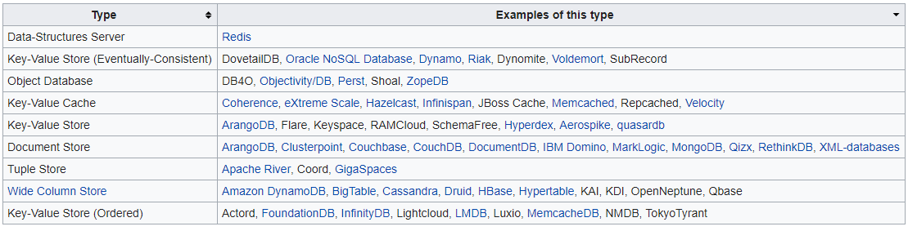
Correlation databases are model-independent, and instead of row-based or column-based storage, use value-based storage.

CAP theorem states that any database system can only attain two out of following states which is Consistency, Availability and Partition Tolerance.
- Consistency: Any changes to a particular record stored in database, in form of inserts, updates or deletes is seen as it is, by other users accessing that record at that particular time. If they don’t see the updated data, it is termed as eventual consistency.
- Availability: The system continues to work and serve data inspite of node failures.
- Partition Tolerance: The database system could be stored based on distributed architecture such as Hadoop (HDFS).
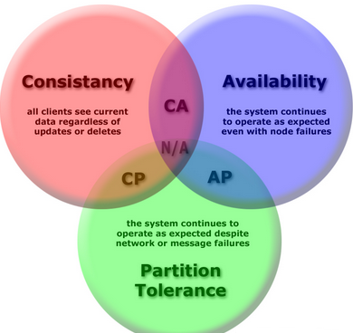
- RDBMS systems such as Oracle, MySQL etc supports consistency and availability.
- NoSQL datastore such as HBase supports Consistency and Partition Tolerance.
- NoSQL datastore such as Cassandra, CouchDB supports Availability and Partition Tolerance.

Which DB system to choose based on CAP requirements?
- CP-based database system: When it is critical that all clients see a consistent view of the database, the users of one node will have to wait for any other nodes to come into agreement before being able to read or write to the database, availability takes a backseat to consistency and one may want to choose database such as HBase that supports CP (Consistency and Partition Tolerance)
- AP-based database system: When there is a requirement that database remain available at all times, one could DB system which allows clients write data to one node of the database without waiting for other nodes to come into agreement. DB system then takes care of data reconciliation at a little later time. This is the state of eventual consistency. In applications which could sacrifice data consistency in return of huge performance, one could select databases such as CouchDB, Cassandra.
HBase Architecture
n HBase, tables are split into regions and are served by the region servers. Regions are vertically divided by column families into “Stores”. Stores are saved as files in HDFS. Shown below is the architecture of HBase.
Note: The term ‘store’ is used for regions to explain the storage structure.
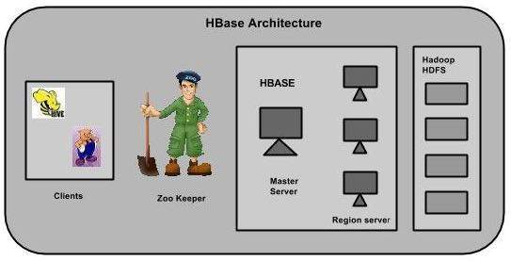
HBase has three major components: the client library, a master server, and region servers. Region servers can be added or removed as per requirement.

MasterServer
The master server -
- Assigns regions to the region servers and takes the help of Apache ZooKeeper for this task.
- Handles load balancing of the regions across region servers. It unloads the busy servers and shifts the regions to less occupied servers.
- Maintains the state of the cluster by negotiating the load balancing.
- Is responsible for schema changes and other metadata operations such as creation of tables and column families.

Regions
Regions are nothing but tables that are split up and spread across the region servers.

Region server
The region servers have regions that -
- Communicate with the client and handle data-related operations.
- Handle read and write requests for all the regions under it.
- Decide the size of the region by following the region size thresholds.
When we take a deeper look into the region server, it contain regions and stores as shown below:
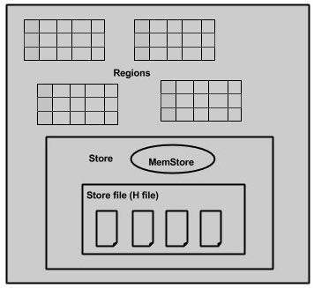
The store contains memory store and HFiles. Memstore is just like a cache memory. Anything that is entered into the HBase is stored here initially. Later, the data is transferred and saved in Hfiles as blocks and the memstore is flushed.

Zookeeper
- Zookeeper is an open-source project that provides services like maintaining configuration information, naming, providing distributed synchronization, etc.
- Zookeeper has ephemeral nodes representing different region servers. Master servers use these nodes to discover available servers.
- In addition to availability, the nodes are also used to track server failures or network partitions.
- Clients communicate with region servers via zookeeper.
- In pseudo and standalone modes, HBase itself will take care of zookeeper.
HBase vs RDBMS
Hadoop and RDBMS are varying concepts of processing, retrieving and storing the data or information. While Hadoop is an open-source Apache project, RDBMS stands for Relational Database Management System. Hadoop framework has been written in Java which makes it scalable and makes it able to support applications that call for high performance standards. Hadoop framework enables the storage of large amounts of data on files systems of multiple computers. Hadoop is configured to allow scalability from a single computer node to several thousands of nodes or independent workstations in a manner that the individual nodes utilize local computer storage CPU processing power and memory.
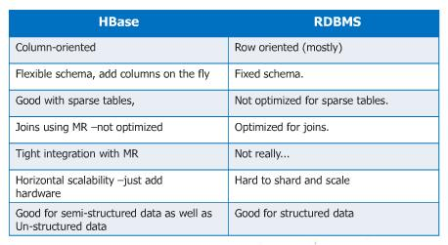
Database Management Systems focus on the data storage in table form which includes columns and rows. SQL is utilized to retrieve needed data which is stored in such tables. The RDBMS concept stores relationships between such tables in various forms so that one column of entries of a particular table will act as a reference for another table. Such column values are known as primary keys and foreign keys with the keys being used to reference other existing tables so that the appropriate data can be related and also be retrieved by combining such tables using SQL queries as required. The tables and relationships can be altered by integrating relevant tables using SQL queries.
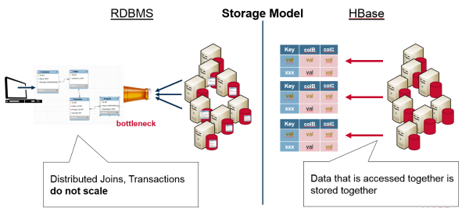

It is important to remember that Hadoop is not an actual database, although HBase and Impala can be considered as databases. Hadoop is just a file system known as Hadoop File System (HDFS) with built-in redundancy and parallelism. Traditional databases or RDBMS’ have “ACID” properties which is an acronym that stands for Atomicity, Consistency, Isolation and Durability. These properties are not found at all in Hadoop. For instance if one has to script code for taking money from one particular bank to deposit the same into another bank then, they will have to painstakingly code all scenarios that may occur such as what happens when money is taken out but a failure results before it is moved into another account.

